York University,
School of the Arts, Media, Performance & Design
York Stage @ Cinespace Film Studios
User Procedures
(rev. 2 14-May-2018)

General:
The Mirkopoulos family of Cinespace Film Studios is providing York University’s School of the Arts, Media, Performance & Design (AMPD) with a state-of-the-art facility for teaching, learning and creation using pioneering motion media technologies. The generous $2.5 million gift from Cinespace Film Studios and the Mirkopoulos family has created the new York University AMPD Motion Media Studio @ Cinespace, embedded at the company’s Kipling Avenue Studio complex.
Located next to professional sound stages being used for major television and film productions, the AMPD Motion Media Studio @ Cinespace will offer students unparalleled experiential learning opportunities, with hands-on training in new media technologies as well as direct exposure to the industry they are preparing to join.

Location & Access
Cinespace Film Studios is located at 777 Kipling Ave., Toronto. The School of Arts, Media, Performance & Design occupies the Motion Media Studio (MMS) which consists of York Stages 1 and 2, and Studios A & B (designed for green room and small classroom/office use).
Entrance: Gate 1 driveway off Kipling Avenue, go to Loading Dock 14 entry door.
By TTC: Bloor Line to Kipling Station and 44 South Bus.
Building Access is 8 AM to 5 PM daily through the Gate 1 loading dock door. After 5 PM, entrance can be gained through the main building entry located at Gate 3.
The main entry doors of Stage 1 & 2 as well as the central corridor separating the two stages are equipped with York University’s proximity access control readers, as are the three equipment storage units located in Stage 1. Studios A & B are accessed by physical keys.

Facilities

Stage 1 is the largest space at the Motion Media Studio. It is used for the purposes of teaching classes in directing, cinematography, and production design. Stage 1 also has fly out walls.

Stage 2 contains a marker-less motion capture system primarily used by faculty researchers, graduate students and instructional class projects. Stage 2 also contains a wet sink area for cleaning.

See Appendix A floor plan.

.
Oversight
The Cinespace Motion Media Space User Committee comprised of AMPD faculty users, AMPD support managers, AMPD student representation and Cinespace Management has planning oversight for the effective use of the space and academic initiatives during the life span of the gift agreement. The committee is co-chaired by a faculty member appointed by the Dean. The AMPD Facilities, Health & Safety Manager acts as a resource co-chair. Co-chairs provides progress reports and committee recommendations to the Dean. The Dean is also a standing member of the committee. Members are invited to join based on curricular and research interest and use of the studios. The User Committee meets monthly on location and provides activity reports and recommendations to the Dean. A donor report outlining initiatives, goals and achievements is prepared annually by the AMPD Senior Development Officer from Advancement Services and is provided to Cinespace Management. The facilities are available to all AMPD departments.
All York University policies and procedures, including the Code of Student Rights & Responsibilities, AMPD Standard Operating Procedures and safety practices, as well as Federal, Provincial, Municipal Act, Statutes and bylaws are applicable to the Motion Media Studio, in addition to those practices and procedures of the Cinespace Film Studios.
Cinema & Media Arts (CMA) users are to also refer to the CMA Student Film Productions and Studio Protocols/SOPs.
The Motion Media Studio is available to all AMPD departments which are encouraged to make use of the facilities for curricular and research initiatives.
Failure to comply with any practice or procedure may result in suspension of use privileges to the Motion Media Studio.
Emergencies and Health & Safety
In the event of a life threatening situation, Call 911 for Fire, Police and Ambulance, and immediately notify Cinespace Security at 416-406-4155 after calling 911.

Provide your location to the 911 Operator as Cinespace Film Studios, 777 Kipling Avenue, Toronto and enter at Gate 3.

As soon as reasonably possible, notify the Faculty Supervisor/Course Director or CMA Studio Manager or the AMPD Facilities, Health & Safety Manager who will in turn provide further direction, investigation and internal University notifications.

* * *

A York University approved standard first aid kit is provided on site in Stage 2 wet sink area. This should only be accessed by those trained in standard first aid. The Record of Use form is to be completed when supplies are used from the first aid kit.

All injuries are to be reported and investigated as per York University accident procedures. The Supervisor’s Accident Investigation Report form is to be used to report employee injury/illness. The York University Incident Report (Non-Employee) form is to be used for non-employees e.g. students and visitors. Blank forms are posted beside the First aid kit and are also available on-line through YU Link.

Parking and Unloading

There are six (6) signed “York University Cinespace Faculty Parking” spaces available for users which are accessible through the Gate 1 driveway off Kipling Avenue, near receiving bay #14. All parked vehicles must display a valid York University parking permit or Cinespace parking permits which can be obtained from the Cinespace Security office located at the main entrance of Gate 3. Unauthorized and/or unidentified vehicles will be ticketed and towed at owner’s expense Toronto By-Law 915-2/7. There is no overnight parking.

All vehicles must display an identification card on the dashboard identifying the driver name and contact phone number (attached in Appendix C). This is not a parking permit, it is for vehicle identification purposes only. Any vehicles that do not display the completed dash card may be immediately tagged and towed at owner’s expense.

The parking lot has a strict zero-tolerance 10 km/h speed limit.

Receiving bay #14 (accessed through Gate 1) may be used to load/unload equipment. Delivery vehicles are expected to be immediately relocated once loading/unloading is completed to facilitate use by other vendors and Cinespace users.

Studio Bookings and Access
Stage 1 must be scheduled 10 business days in advance of use through the Co-Chairs of the User Committee (see page 7).

The Cinespace Motion Media Key Ring can be signed out from the Department of Cinema and Media Arts one business day in advance of the reservation and must be returned within one business day of completion of reservation unless pre-arrangements are made with a Co-Chair.

Failure to return the key ring in a timely fashion may result in delays for subsequent bookings and student production shoots.

The Cinespace Motion Media Key Ring contains a proximity reader access fob which accesses all proximity readers 24/7, keys for Studios A and Studio B, and an equipment garage storage key). CMA student users are encouraged to document their film shoot projects with still photos.

An orientation may be arranged for users on facility use conducted by Cinespace Management.

Stage 2 and Motion Capture is reserved primarily for research and graduate use.

Cinespace Security will not provide access.

Pre-authorized executive members and faculty users of the Motion Media Studio are able to sign out the York Stage key ring from Cinespace Security if required, e.g. if their access card fails etc.

Current York employees and or student card badge holders may be granted temporary or permanent proximity access privileges with approvals by the committee co-chairs

There is also a duplicate Cinespace Motion Media Key Ring located in the Longford Key Box located by the single corridor door in the loading dock. Access to this key box is by a code and must be authorized by the AMPD Facilities, Health & Safety and Technical Services Manager.

In the event the Key Ring is lost, the assigned user is to report immediately to their Faculty Supervisor, as well as the Manager, Facilities, Health & Safety, AMPD. The user will be responsible for the cost of access fob replacement and or re-keying of locks.

House Keeping

It is the responsibility of all users to maintain cleanliness throughout pre-production, production and/or general use to mitigate hazards and to ensure safe use. Upon completion of use, users are to ensure space is returned to the standard proscribed and/or state it was found so the space is clean and ready for the next production or class.

The Motion Media Studio is equipped with a dust mop, industrial broom, wet-dry vacuums and a mobile bucket wringer and wet mop. Users must supply their own work tools, building and cleaning supplies (garbage bags, paper towels etc.).

All users must complete the Strike Checklist (see Appendix D) when upon completion of studio use and this must be submitted with the key return.

Please note that the MoCap system located in Stage 2 requires a dust free environment, therefore no sanding or sawing of materials that will create airborne dust particles is permitted. Only the wet/dry vacuum is permitted to be used in this area and not dust mops.

On occasion users will require access to both stages for access to equipment, supplies or to HVAC and IT controls. Users need to be respectful to each other’s use and if access is appropriate at any given moment. Both stages are equipped with LED light control strips above entry doors and a bell alert. There are two remotes available to trigger audible and visual alerts when filming and/or when MoCap activity is in progress to avoid interruptions.

Waste Disposal

Users are responsible to remove any leftover building materials, paints, created sets and/ or food refuse/containers upon completion of use.

Cinespace does not provide for recycling or composting.

Any user requiring a general carpentry waste bin must identify this need at the time of a studio booking. Metal waste bins will be arranged through Cinespace and their Vendor of Record. Fees may apply to users for this service.

Food waste and containers must be removed by all users to mitigate pest infestation.

HVAC & Electrical Breaker Panels

The single heating/cooling/fan control for both stages is located in Stage 1 corner where the IT systems, electrical breaker panels and room light switches are. The fan control is currently set to the Auto mode, but can be switched off for filming. Temperature can be manually adjusted at time of use for optimum comfort. Users are to return the temperature setting to 68 F degrees (or 20 C) and switch the fan to Auto mode when finished use.

This area of Stage 1 is demarked as a non-work area due the location of electrical breaker panels and IT panels.

Use of Special and Physical Effects

Any use of special effects (e.g. fog machines), physical effects not in standard use in the Motion Media Studio or within AMPD curriculum, including use of replica weaponry and fight choreography must be approved in advance by the appropriate faculty supervisor in consultation with the CMA Studio Manager, AMPD Manager, Facilities, Health & Safety and Cinespace Film Studios in order to complete a risk-hazard assessment.

Special/physical effects include but not limited to:

- Smoke (artificial or real)
- Open flame of any size
- Extreme heat
- Plumbing/welding
- Water
- Projectiles

Request of special effect use must be identified upon booking and also approved by Cinespace Management, as isolation or shut down of the building fire alarm detection devices may be required. Feels may be incurred by the user for fire isolation and fire watch personnel.

In some circumstances depending on the scope of the activity, a faculty supervisor/course director may need to be present to provide duty of care. In addition, the use of replica firearms requires additional approvals from York University Security Services and in some instances Toronto Police Services.

Service Requests

Any recommendation or request for equipment and or supply purchases and/or facility alterations are to be sent to the attention of the Motion Media Studio Committee Co-Chairs.

The Cinespace Film Studio Tenant Request form (see appendix B) is to be utilized by the co-chairs for services that require the use of Cinespace Film Studios staff or resources.

Film Equipment, Ladders & Peripherals

All equipment provided through generous donations by Cinespace and others, as well as equipment leases through PS Equipment, and purchased by AMPD is available for use to authorized users and for scheduled bookings. Priority use is for students using Cinespace. This equipment may not be taken off site with the exception of service needs as arranged by the CMA Studio Manager. Please report any broken or missing equipment to the CMA Studio Manager and label the piece as “out of service”.

All equipment is inventoried and PS equipment is labelled with PS identifying barcodes. AMPD purchased equipment is labelled accordingly.
When not in use, equipment is to be stored in its designated storage location.
When not in use, all ladders must be stored in an upright position and chained in their designated storage locations.
All ladders must be inspected prior to use. Inspection Check List forms and MOL Ladder Fast Fact Use Tips are located at each ladder storage area.
Physical assets are further monitored by the use of digitally recorded localized CCTV cameras.
While it is encouraged that users work in groups, especially outside of Cinespace Film Studio business hours, there may be occasions where only one or few users may be present. In such cases, the user can alert Cinespace Security at 416-406-4155 to advise of working alone.

External Client Rentals

External client and/or internal York University user rentals will be subject to all Cinespace Film Studio and York University policies and procedures, insurance and risk requirements, and established AMPD rental fees. Also see AMPD Studio Booking Procedures.

Committee Co-Chairs:

John Greyson
Associate Professor
Cinema & Media Arts
greyzone@gmail.com

Terry Wright
Manager, Facilities, Health & Safety and Technical Services
Office of the Dean, AMPD
Wright1@yorku.ca
Cell: 416-676-6677

Appendix A

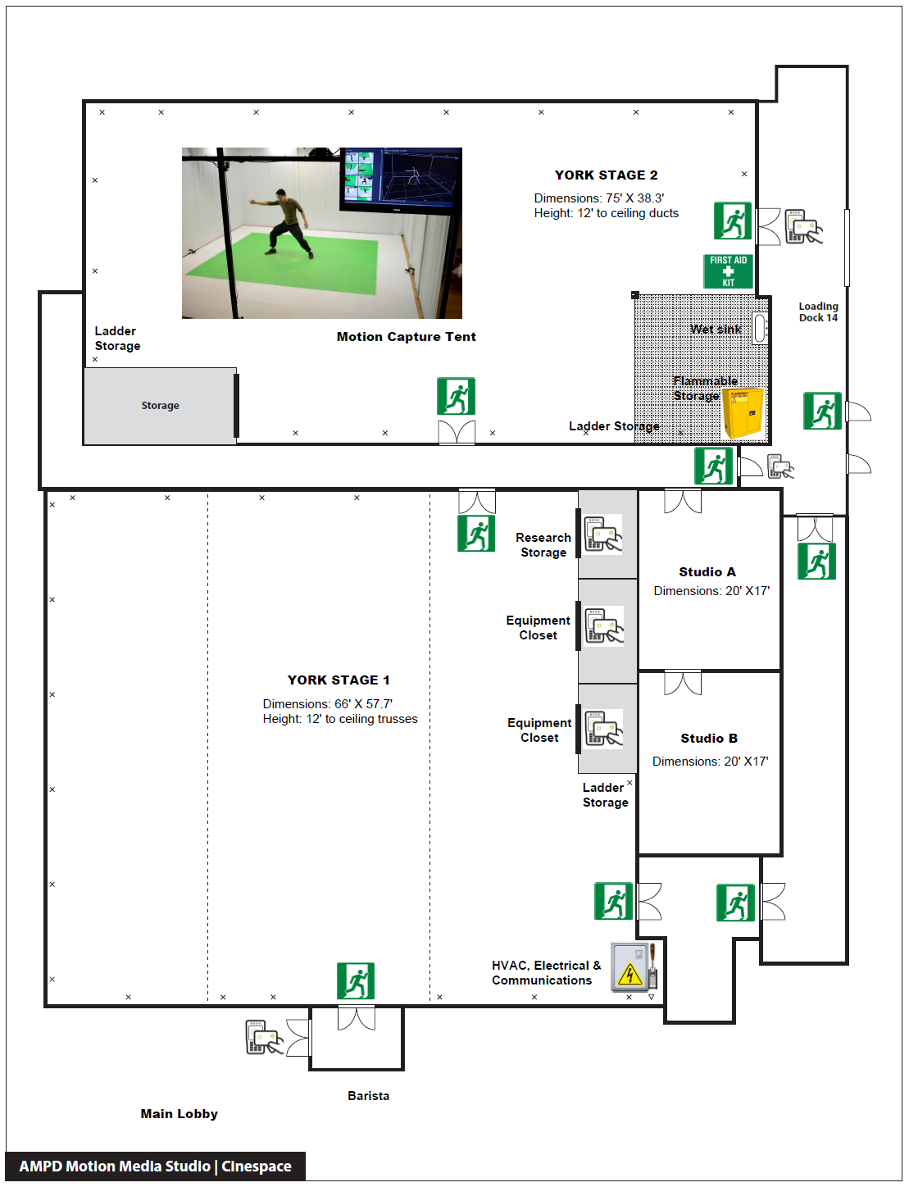

Appendix B

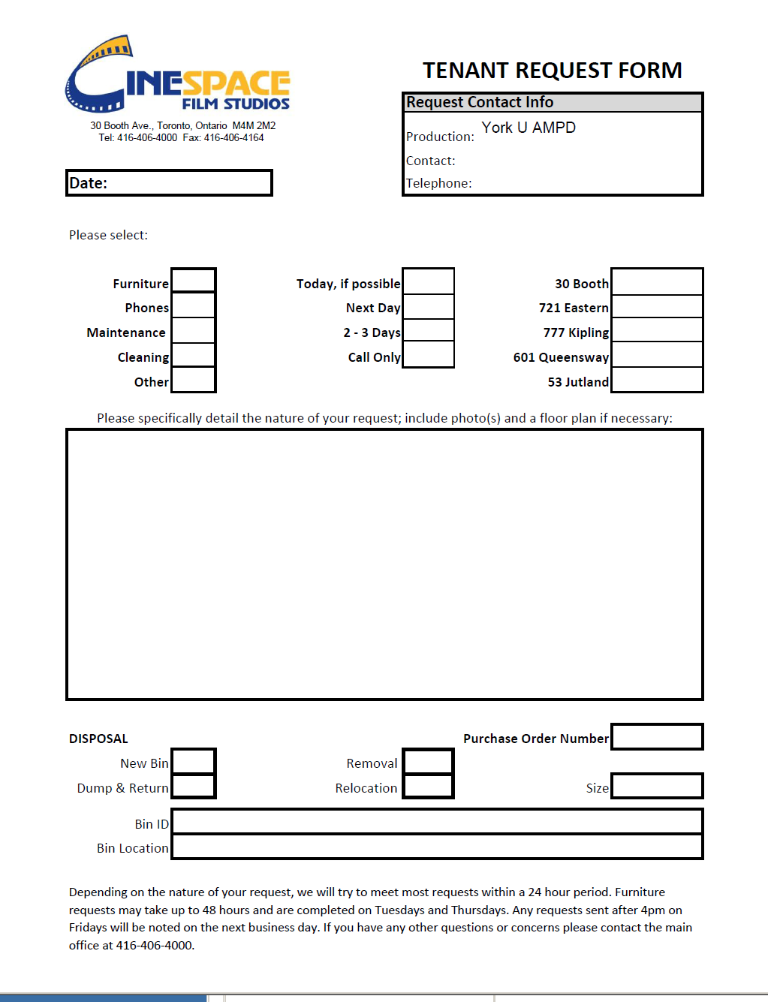

Appendix D

Motion Media Lab Strike Check List

All food waste and containers removed from studios YES / NO (no exceptions, kindly dispose of).
All construction materials (sets, props, paints, construction waste) removed YES / NO (if no, please explain, however authorization needs to occur prior to using the studio): __________________________________________________________________________________________________________________________________________________________________________
All AMPD York U equipment has been returned to designated storage closets/area. YES / NO (no exceptions, kindly return to designated storage).
All ladders used have been returned and chained in their designated areas YES / Not Used
Floors swept and or vacuumed YES / Not required
Were any First Aid supplies utililized? YES / NO (If yes, ensure appropriate accident report has been completed).
HVAC control has been reset to to 68 F degrees (or 20 C) and the fan switched to Auto mode YES / NO (if no, explain: _____________________________________________________________________________________

All exits and access to fire extinguishers and first aid kit is free of debris, clutter or other obstruction YES / NO (if no, explain): __________________________________________________________________________________________________________________________________________________________________________
Name (print): ___________________________ Signature: ___________________________________

Any issues/deficiencies to be reported to User Committee Co-Chairs.
Keys to be returned along with the completed checklist within one business day.
Users will be billed for any disposal or clean up required as a result of non-compliance.
Thank you.

